**Pharmacy Management System**

**Introduction:**

The main aim of the project is to manage a pharmacy. This project implements the management of staffs of a pharmacy. The aim of the project is to develop an online web application that can be used to manage a pharmacy.

In this project we have implemented only pharmacy staff management, by using this one can manage Pharmacy staffs like adding, editing or deleting a staff member of the pharmacy. We can also assign role to a staff member.

In this project we have assumed four roles in a pharmacy –

1. Admin

2. Manager

3. Pharmacist

4. Salesman

**Admin:**

Admin is the main role in our pharmacy management system project. An admin has all the access to the software. He can do everything that can be done in our pharmacy management system project. An admin can do the following things –

1. Manage Manager
2. Add a manager
3. Edit a manager
4. Delete a manager
5. Manager Pharmacist
6. Add a pharmacist
7. Edit a pharmacist
8. Delete a pharmacist
9. Manager salesman
10. Add a salesman
11. Edit a salesman
12. Delete a salesman
13. Change password

**Manager:**

Manager is the second role in our pharmacy management system project. A manager has also all the access to the software. He can do everything that can be done in our pharmacy management system project. A manager can do the following things –

a. Manage Manager

1. Add a manager
2. Edit a manager
3. Delete a manager
4. Manager Pharmacist
5. Add a pharmacist
6. Edit a pharmacist
7. Delete a pharmacist
8. Manager salesman
9. Add a salesman
10. Edit a salesman
11. Delete a salesman
12. Change password

**Pharmacist:**

Pharmacist is the third role in our pharmacy management system project. A pharmacist has less access than Manager to the software. He can do all the things except managing manager. A pharmacist can do the following things –

a. Manager Pharmacist

1. Add a pharmacist
2. Edit a pharmacist
3. Delete a pharmacist
4. Manager salesman
5. Add a salesman
6. Edit a salesman
7. Delete a salesman
8. Change password

**Salesman:**

Salesman is the fourth role in our pharmacy management system project. A salesman has less access than pharmacist to the software. He can do all the things except managing manager and pharmacist. A salesman can also update his/her total daily sale. A salesman can do the following things –

a. Manager salesman

1. Add a salesman
2. Edit a salesman
3. Delete a salesman
4. Change password
5. Update total sale

**Software used:**

In this project we have used some software those are –

1. Text editor (Atom)
2. Local server (Xampp)
3. Browser (Chrome)

**Database tables:**

In this project we have used a small database that contain some tables to store related data of the project.

We have used separate tables for all the roles to store related data.

Database contain the following tables –

1. Admins
2. Managers
3. Pharmacists
4. Salesmans

These tables store the data to their corresponding roles like managers table contain all the data of all the mangers and pharmacists table contain all the data of all the pharmacists.

**Schemas:**

1. Admins (id, fname, lname, email, password, role)
2. Managers (id, fname, lname, email, password, mobile, role)
3. Pharmacists (id, fname, lname, email, password, mobile, role)
4. Salesmans (id, fname, lname, email, password, mobile, role, total_sale)

**ER diagram:**

**[**In next page**]**

**managers**

Manage

**Admins**

Manage

**Pharmacists**

Manage

**salesmans**

**Some screenshots of the project:**

1. **Login page**

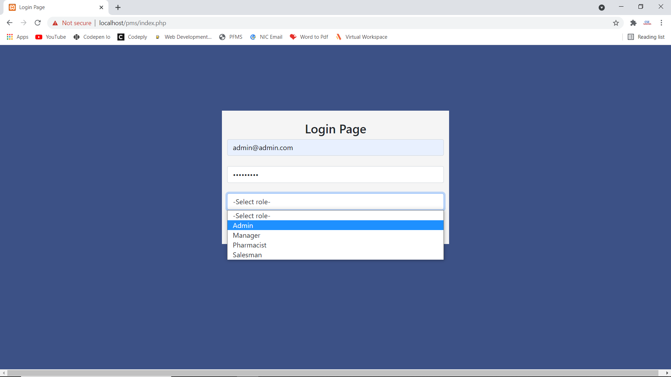

1. **Admin Dashboard page**

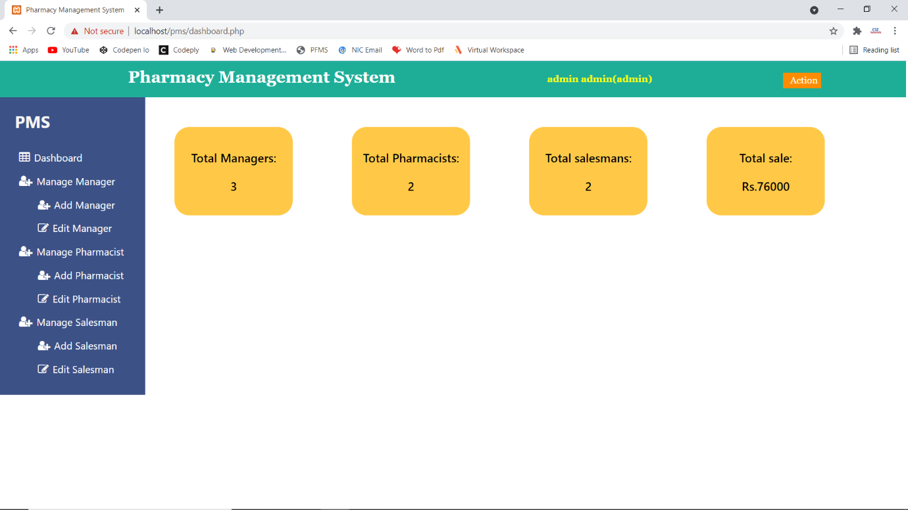

1. **Add Manager Page**

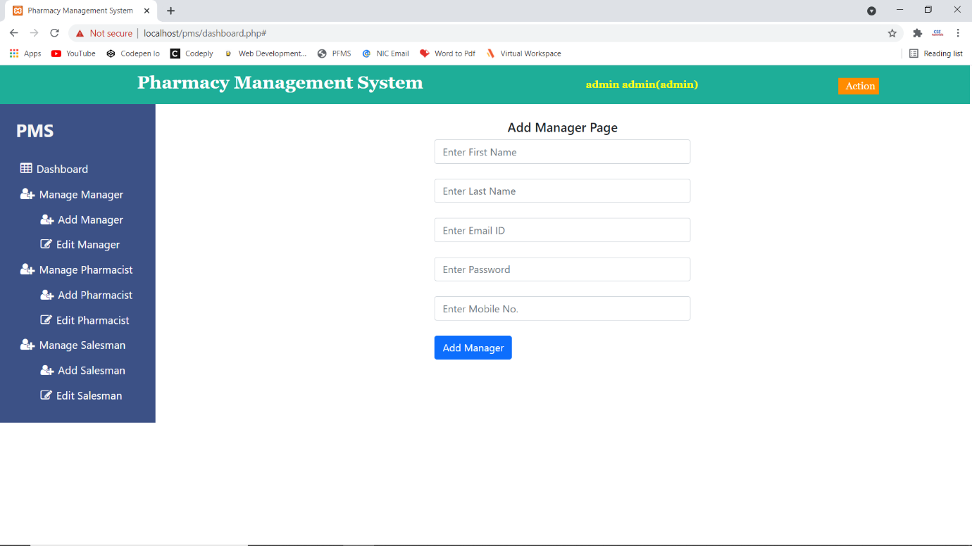

1. **Edit Manager Page:**

